

**re:Invent 2019**

**ARC319**

**Security Vulnerability Identification and Remediation**

Copyright © 2019 Amazon Web Services, Inc. or its affiliates. All rights reserved.

This work may not be reproduced or redistributed, in whole or in part, without prior written permission from Amazon Web Services, Inc. Commercial copying, lending, or selling is prohibited.

All trademarks are the property of their owners.

Table of Contents

Prerequisites 4

Problem Statement 5

Solution Overview 6

Task 1 – Enable AWS Config and AWS Security Hub 7

Task 2 – Deploy the Three Tier Web App CloudFormation Template 9

Task 3 – Check your security findings 10

Task 3 – Create AWS Config rules/remediations 10

Task 4 – Review the AWS Config deployed rules 10

Task 5 – Review the Security Hub findings – Needs Screenshots 11

Task 6 – Create a new AWS Config Rule 11

Task 7 – Additional Testing 13

Task 8 – Cleanup 13

Task 9 – Optional (further reading/discussion) 13

Appendix A: Troubleshooting common issues 14

# Prerequisites

This exercise requires access to Amazon Web Services. (AWS) console. You will be provided with a pre-provisioned AWS account and console access. As this is a 300-level workshop, it is assumed that you already have the knowledge required to satisfy the prerequisites for the workshop.

# Problem Statement

You are the lead DevSecOps engineer for a large global conglomerate. Various business lines are grown primarily through mergers and acquisitions. Your company just bought a new startup that specializes in an online blogging platform; and you have been asked to implement the technology stack that was acquired. The technology stack was done as infrastructure as code in a CloudFormation Template. This will be cake…. Right?

This workshop focuses on integrating the new web platform and ensuring a proper security posture is maintained. The lab will involve learning how to monitor, alert, and remediate security events in your AWS environments; primarily focusing on [AWS Config](https://aws.amazon.com/config/) and [AWS Security Hub](https://aws.amazon.com/security-hub/).

**\*\*\*ARC319 will provide scripts and templates that intentionally create security holes, to be remediated. These templates should ONLY be deployed into temporary/sandbox AWS accounts and not into your corporate environment or anywhere with sensitive data.**

# Solution Overview

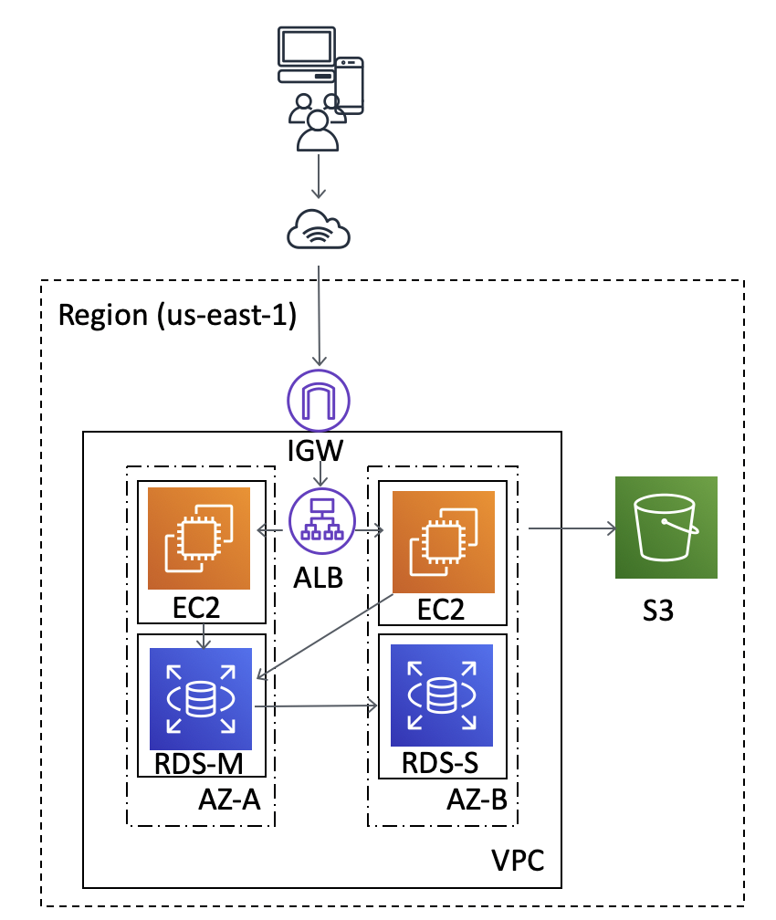

The solution diagram, shown above, is to deployed into the AWS region –us-east-1 (N. Virginia); and

The architecture provides a WordPress environment to host the online blogging platform. AWS services included are [Amazon EC2](https://aws.amazon.com/ec2/), [Amazon S3](https://aws.amazon.com/s3/), and [Amazon RDS.](https://aws.amazon.com/rds/)

In the workshop, you will need to ensure that the new technology stack fits within your company’s security posture. Your company is fairly new to AWS but has heard about services like [AWS Config](https://aws.amazon.com/config/), [AWS Security Hub](https://aws.amazon.com/security-hub/), [Amazon GuardDuty](https://aws.amazon.com/guardduty/), and [Amazon Macie](https://aws.amazon.com/macie/) to help secure their environment. This lab will focus on the **AWS Config** and **AWS Security Hub** for detective controls and remediation.

# Task 1 – Enable AWS Config and AWS Security Hub

AWS Security Hub requires AWS Config to be turned on. Let’s do that first.

Enable AWS Config

1. Log into the AWS console with the link and credentials provided by the lab instructor
2. Ensure your region is N. Virginia (in the top right navigation bar)
3. Navigate to the AWS Config service (click services at the top; Config is under ‘Management & Governance’)
4. If you get the screen below, click ‘Get Started’



1. Choose to use the redesigned interface, if prompted

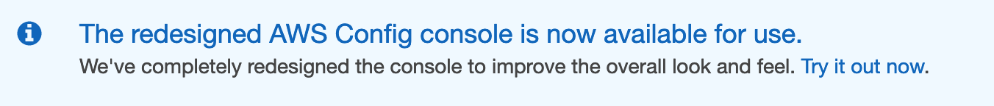

1. Click the navigation icon in the top left () and choose Settings
2. Click ‘Edit’ in the top right of the Settings page
3. Enable the AWS Config Recorder
   1. Under Recorder select ‘Enable Recording’

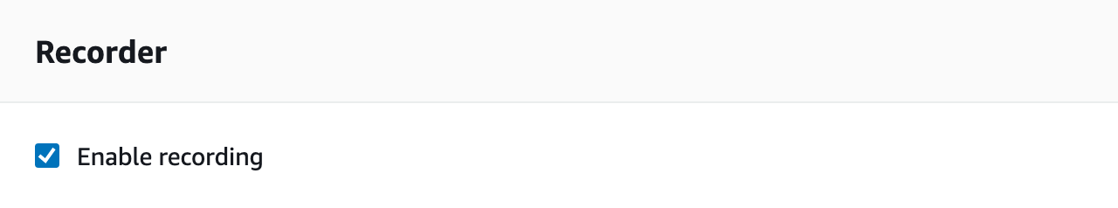

* 1. Under General Settings change the AWS Config Role option to ‘Use an existing AWS Config service-linked role’

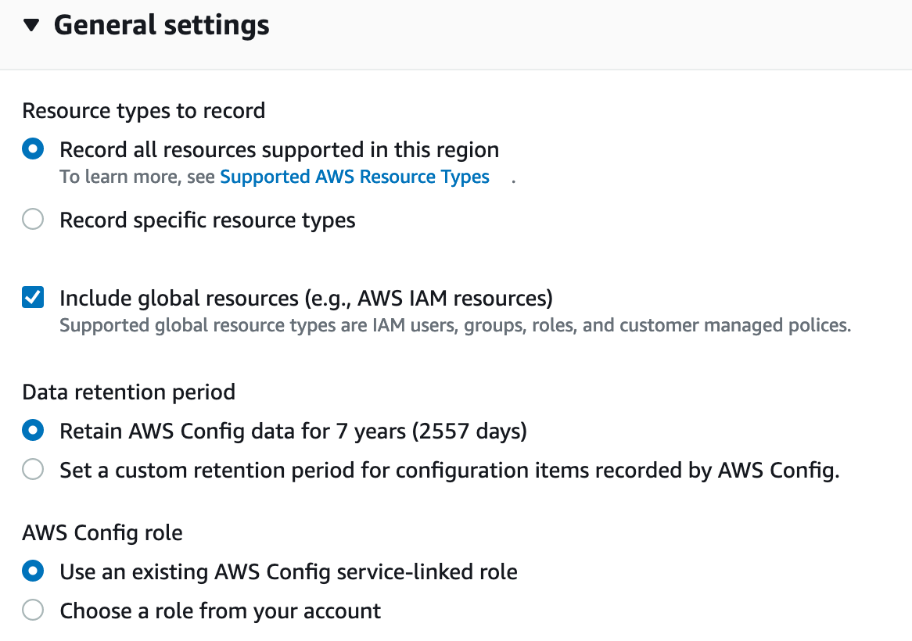

* 1. Under Delivery Method -> S3 Bucket chose ‘Create a bucket’

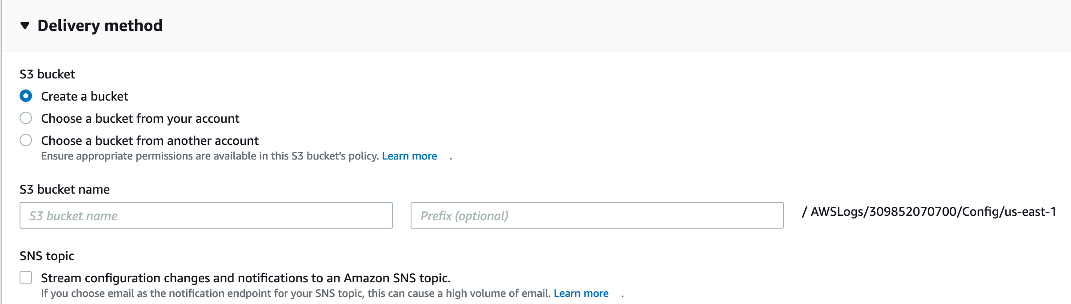

* 1. Click Save

Enable AWS Security Hub

1. Navigate to the AWS Security Hub service (click services at the top; Security Hub is under ‘Security, Identity, & Compliance’)
2. If you get the screen below, click ‘Go to Security Hub’

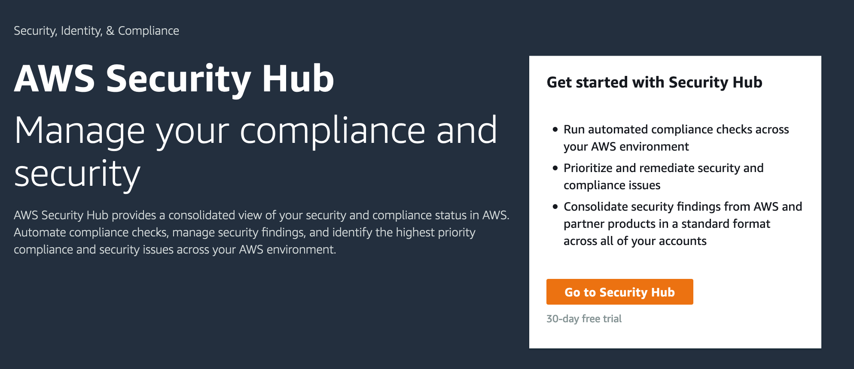

1. On the next screen click ‘Enable AWS Security Hub’

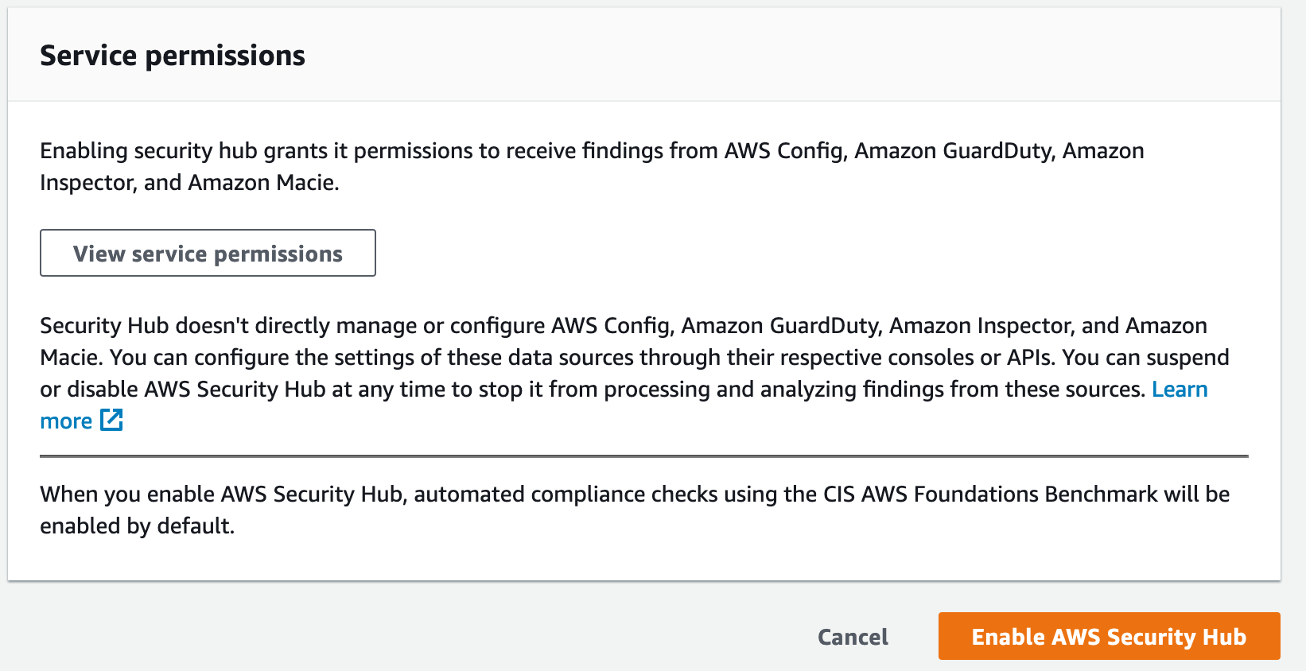

# Task 2 – Deploy the Three Tier Web App CloudFormation Template

**\*\*\*The steps below will deploy an environment with intentional security vulnerabilities, this template should ONLY be deployed into temporary/sandbox AWS accounts and not into your corporate environment or anywhere with sensitive data.**

Launch the AWS Three Tier Web App CloudFormation stack in us-east-1 (N. Virginia):

 Will need to add the hyperlink

The link opens the CloudFormation console in your account in us-east-1 region.

1. In ‘Select Template’, click Next.
2. Under ‘Specify Details’, click Next
3. In the Options section, scroll down to the bottom and click Next.
4. In the Review section, scroll down to the bottom, check the “I acknowledge…” checkbox and click Create. You may have to click the refresh button in CloudFormation console for the stack to appear; it should show CREATE_IN_PROGRESS under Status.

While the CloudFormation stack is being created open the CloudFormation Template in the editor of your choice.

**Discussion: Do you see anything that might generate security concerns?**

# Task 3 – Check your security findings

1. Navigate to the AWS Security Hub service (click services at the top; Security Hub is under ‘Security, Identity, & Compliance’)
2. Click on Findings

We can see that several vulnerability findings are listed. This is great for an environment that is regularly monitored, unfortunately yours is not.

**Discussion: How could you enable automated remediation for these findings?**

# Task 3 – Create AWS Config rules/remediations

Launch the AWS Config CloudFormation stack in us-east-1 (N. Virginia):

 Will need to add the hyperlink

The link opens the CloudFormation console in your account in us-east-1 region.

1. In ‘Select Template’, click Next.
2. Under ‘Specify Details’
   1. ChangeMyIPAddress (enter your current IP Address; from <https://whatismyipaddress.com>)
   2. Enter an email that you have access to in MyEmailAddress; this will be used for remediation notifications
   3. Leave the defaults for TagCostCenterValue, TagWorkloadValue, and TagOwnerValue
3. In the Options section, scroll down to the bottom and click Next.
4. In the Review section, scroll down to the bottom, check the “I acknowledge…” checkbox and click Create. You may have to click the refresh button in CloudFormation console for the stack to appear; it should show CREATE_IN_PROGRESS under Status.

While the stacks are being built, we will discuss details around creating AWS Config rules and options that exist for remediation.

# Task 4 – Review the AWS Config deployed rules

When the CloudFormation stack is complete:

1. Click the ‘outputs’ tab within the CloudFormation stack and make note of the *IAMRoleArn value* (you will need this later)
2. Navigate to the AWS Config service (click services at the top; Config is under ‘Management & Governance’)
3. Choose to use the redesigned interface if prompted



1. Click the navigation icon in the top left () and choose Rules
2. Sort the rules by name (don’t focus on those that start with ‘securityhub….’
3. Look at the rule titled ‘S3_BUCKET_PUBLIC_READ_PROHIBITED’
   1. Click the rule name
   2. In the rule window click on Remediation Actions
   3. We see that this rule is being remediated with a Systems Manager pre-defined remediation
4. Now look at the rule titled ‘IAM_POLICY_NO_STATEMENTS_WITH_ADMIN_ACCESS’
   1. Click the rule name
   2. In the rule window click on Remediation Actions
      1. Notice that there is no remediation action selected here
      2. This rule doesn’t have a corresponding AWS Systems Manager pre-defined remediation; it is being remediated with a custom Lambda Function
5. Open AWS Lambda (click services at the top; Lambda is under ‘Compute’)
   1. Open the Lambda function named ‘xxxxxx’
   2. Review the Lambda function to understand how it is remediating the overly permissive security groups

# Task 5 – Review the Security Hub findings – Needs Screenshots

1. Navigate to the AWS Security Hub service (click services at the top; Security Hub is under ‘Security, Identity, & Compliance’)
2. Click on Findings
3. Notice the additional findings that are represented based on the newly deployed AWS Config rules as well as those enabled by default with Security Hub

**Discussion – AWS Security Hub is a centralized service to review aggregated and normalized findings. What other AWS Security services (and 3rd party solutions) could integrate?**

# Task 6 – Create a new AWS Config Rule

1. Navigate to the AWS Config service (click services at the top; Config is under ‘Management & Governance’)
2. Choose to use the redesigned interface if prompted



1. Click the navigation icon in the top left () and choose Rules
2. Click ‘Add Rule’



1. Select the ‘Add AWS managed or custom rules’ option

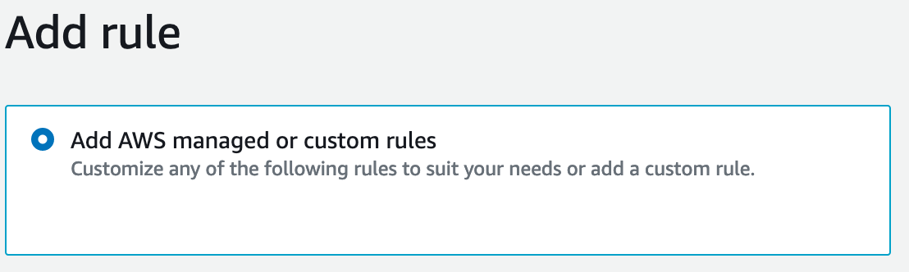

1. Search for Encryption and select ‘s3-bucket-server-side-encryption-ena…’

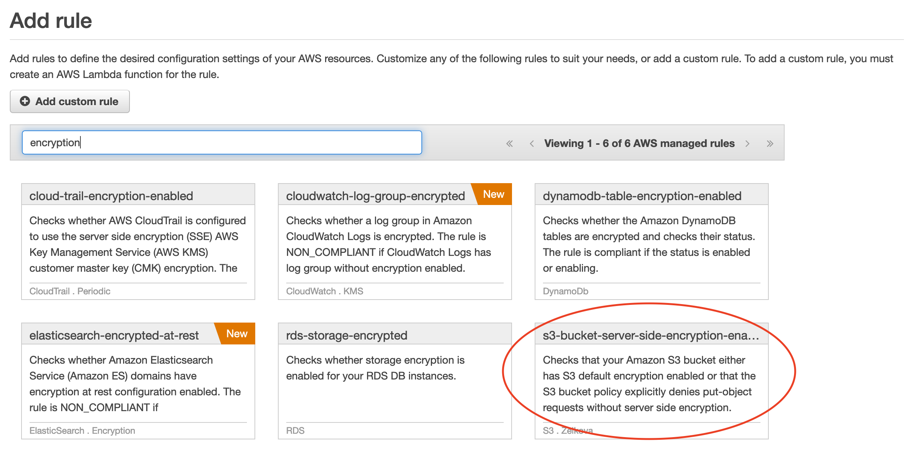

1. Leave the defaults up until the ‘Choose Remediation Section’
2. Modify the following settings
   1. Remediation Action: choose ‘AWS-EnableS3BucketEncryption’
   2. Change Auto Remediation to ‘Yes’
   3. Resource ID Parameter: choose ‘BucketName’

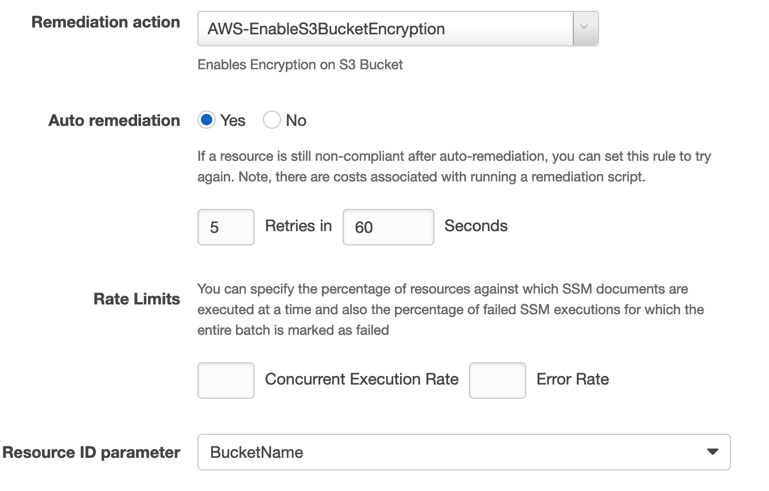

* 1. In the parameters section change Automation Assume Role to the arn of the IAM role created in the Task 3 (‘IAMRoleArn’ Noted earlier)
  2. Leave SSE Algorithm as ‘AES256’

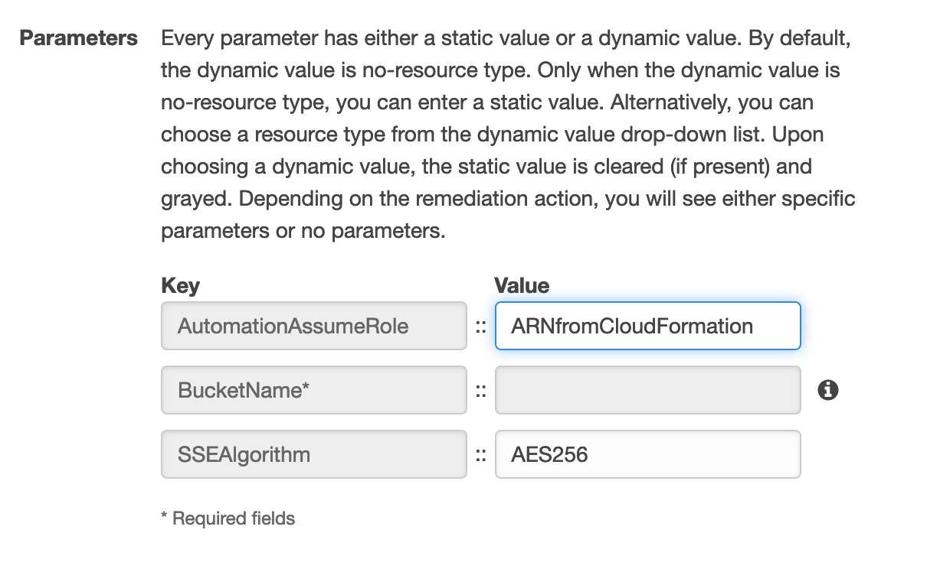

* 1. Click Save
  2. Check the rule status and verify that encryption was turned on for your S3 Bucket

# Task 7 – Additional Testing

Now that you have deployed the environment and remediated the security vulnerabilities through a combination of AWS Config and AWS Security Hub test out deploying resources with known vulnerabilities.

Examples

* Create a new EC2 instance with SSH open to the public internet
* Create a new S3 bucket not encrypted with public read/write settings

Once deployed go back in and check the settings.

**Do the vulnerabilities still exist?**

# Task 8 – Cleanup

As these are temporary accounts, environments will be deleted upon completion. However; best practices would indicate to delete each deployed CloudFormation stack to avoid incurring additional costs.

# Task 9 – Optional (further reading/discussion)

# Appendix A: Troubleshooting common issues

**Problem**: My CloudFormation stack shows failed after I attempt to delete it.

**Fix**: Sometimes Config Rules with remediations fail to delete through the CloudFormation process. If you experience this, go into AWS Config and delete the rules, then delete the CloudFormation stack; it will then succeed.

**Problem:** I created a new AWS Config rule but the remediation isn’t working.

**Fix**: Verify that you used the IAMRoleArn from the Config CloudFormation deployment. Additionally, if you chose a different remediation you will need to update the IAM role with proper policies.

**Problem:** I don’t see the stack that I deployed.

**Fix:** Verify that you are working in the US-East-1 region.